

**Project - Hi-fidelity Prototype**

**Submitted By:**

**Name:** Khalid Hasan Seum

**Submitted To:**

**Name:** Andrew Chiou

Lead Lecturer,

CQUniversity, Sydney.

Contents

Introduction: 3

Content: 4

Home Page: 4

All Category: 5

Fountain Pen, Marker, Watercolour Webpage: 6

Opening Hour Webpage: 6

User Acceptance Test: 7

Results: 9

Features: 11

Recommendation: 12

Conclusion: 13

Appendix: 14

# Introduction:

Modern Sketching Tools is a physical shop and they wanted a website to provide the information to customer about their product information, the shop’s floor plan, their business hour (open and closing time and date), and contact details. The shop owner doesn’t want to sell anything in the website. So, the main purpose of the website is to provide information so that customer can make decision easily and find out their desired product in a particular section. There is already a lo-fi fidelity prototype for the website but later the user finds out some problem and they also have so suggestion to make the website useful and better. Based on their recommendation, we have to update and upgrade the prototype of the webpage and make a final website. This prototyping is called hi-fidelity prototyping and we have to provide report based onto it. The report contains the hi-fidelity prototype, full website walks through, features, acceptance test and recommendations.

# Content:

The website follows all the golden rules of the web interface design. If we visit the website’s home page then we can see every section have same background colour, all the text formatted in a particular format, and we can see the full webpage is consistence. All the webpage of the webpage is consistence. So, the website is maintaining the strive for consistency rules. The webpage is providing user usability. Any user can use this website because of it’s easy interface. Every products has their name, price and availability and a very easy navigation is being used for making sure any age group people can use the website properly. The website is also keep users in control. The website never get change suddenly. An experienced user wants to be in charge of the interface and that the interface responds to their action. The website always ensure that by not getting change by it’s own. Every webpage have a slider option. If we scroll down then we can see an icon on the right side and if we press the icon the scroll up the webpage. For more visual representation we can see appendix (Fig.1 – Fig.4)

## Home Page:

In the home page in the upper section contains the website’s logo and all required menus so that one customer/user can easily move from one webpage to another page. On the right side of the upper menu we can see there is an option for dark mode and day mode and this thing is one of the important things for the user as the dark theme is useful for nighttime website surfing. If we press the moon icon then the website will turn into dark mode and the web page's contents will shift their color for greater visuality. For more visual representation we can see (Fig.1 – Fig.4)

If we click on the floor plan then the webpage will scroll down toward to floor plan section and it’ll show the floor plan. Same thing will happens with the products option and new option. Besides, if we click all category and opening hours then it will redirect into the particular page.

In the middle section, we can see there is a welcome message and on the left side there are social media links for the customer who want to join in the shop’s social media account for more updated information. In the underneath of the welcome we can see there is a *discover* option for open up the all types of products category webpage and check different type of products.

There is a *floor plan* of the shop for the user who wants to check the shop’s *floor plan* and which section contains the particular products. Users can select any category for the map to see the particular section. If a customer clicks the *fountain pen* on the map then he will redirect to the *fountain pen* webpage.

After the floor section we can see there is another section for Featured products. If we move our mouse cursore over any of the featured items then we can see the product item getting extended and it’s showing it’s the corresponding category. As we can see the Hero 901 product is showing that it belongs to the *fountain pen* category.

There is a products section where we can see the products of the shop and there is an option to see more. This option will take us on to the *all category* webpage. If we move the mouse on the products then we can see there is a hover effect. We can see shadow in the background of the products .

After the products section, there are some speeches of the marketing manager, executive director, and national manager. There are two indicators to move one speech to another.

After the speech section, there is a new arrival section where we can see new products and upcoming products. If we move the cursor to one of the products it’ll show which products are available and which will be available soon. There is another function that is the products are rolling. If we right-click on any products and move to the right or left then more products will come forward to us.

After this, we can see there is a newsletter section. If a customer wants to get updates about the products then he can subscribe to the shop’s newsletter.

The bottom section of the webpage contains the address of the shop and contact number. It’s also providing the opening hours, all products option to open up the all category webpage and there is another column that contains different sections of the products. In addition, there is another column for the social media account and page information so that a user can stay connected through social media. There is also copyright information in the bottom section.

## All Category:

On the all-category webpage, we can see all types of products. If we see at the upper section then we can see the logo on the left side. In the menu section, there are options for home, all categories, fountain pen, marker, watercolor, and opening hours. It is different from the home menu.

In the body section, we can see the fountain pen, marker, and watercolor sections and their products. In the fountain pen sections, we can see all the fountain pens that are available in the store. The same goes for the other category. We can see the product availability and if we move our mouse to one of the products then the section will get extended and we can see the product descriptions. We can also see the background shadow when we move the mouse throughout the website. In every product, we can also see the product name and price with their picture.

The newsletter and bottom section are the same as the home page. For more visual representation we can see appendix (Fig.5 – Fig.6)

## Fountain Pen, Marker, Watercolour Webpage:

The upper part and the bottom section are the same as all category webpage. In the middle section of the fountain webpage, all the fountain pens are listed with their price, availability, and description. The same goes for marker pen and watercolor. For more visual representation we can see appendix (Fig.7 – Fig.9)

## Opening Hour Webpage:

The upper part and the bottom section are the same as all category webpage.

In the middle section, there is a list of the day, start time, finish time. This list also included which day will be closed day. This table gives the customer a complete idea of when the shop will be open and when the shop will be closed. For more visual representation we can see appendix (Fig.10)

# User Acceptance Test:

For the acceptance test, I need some users who will test the website so that they use the website and we can calculate the error. I asked my 5 friends to test the website. The details of the 5 users below:

User 1:

Name: Jimme Kang

Profession: Student (BIT in Software Development)

University: Central Queensland University, Sydney.

User 2:

Name: Prasanna Shresta

Profession: Student (BIT in Business Analytics)

University: Central Queensland University, Sydney.

User 3:

Name: Akmam Hasan

Profession: Student.

Major: BSC in Computer Science and Engineering.

User 4:

Name: Obantika Roy

Profession: Student.

Major: BSC in Computer Science and Engineering.

User 5:

Name: Sadia Sultana Tasnia

Profession: Student.

Major: BSC in Computer Science and Engineering.

I asked every user to go to the home page of the website and then go to the All Category webpage and then click on the water colour from menu. After that return from water colour page to the webpage. Generally, it takes only 4 attempts and 18 seconds to complete the full walkthrough. If any error happens it takes 5 seconds of time to solve.

User 1, firstly go to the All Category webpage and then she made an error. She clicked on the Marker section instead of Fountain Pen. After than she click to the back button and return to the previous page and then she click the right menu option. After that she successfully comeback to the home page without any error. She needed total 6 attempts to complete the task. She needed total 30 seconds to do the task and for solving the error she needed 6 seconds. Besides in the error she was in for 7 seconds.

User 2 visit the water colour webpage successfully but when she returned back from the webpage she clicked opening hours. After that she return back from the webpage and successfully return back to the home page. She needed total 6 attempts to complete the task. She needed total 32 sec to do the task and for solving the error she needed 5 seconds. Besides in the error she was in for 7 seconds.

User 3 finished the task successfully without any error. So she only needed 4 attempts and 20 seconds to complete the task.

User 4 clicked opening hour instead of all category and after that he back to the homepage again and then click the all category option and then he clicken fountain pen website successfully but while returning from the webpage, she clicked marker section instead of the back button. Then he again press back button and return to the home page. He needed total 8 attempts to complete the task. He needed total 40 sec to do the task and for solving the error he needed 8 seconds. Besides in the error he was in for 14 seconds.

User 5 visit the all category webpage and then she clicked on the water colour instead of fountain pen. Then she go to opening hours instead of return. After that she solved her error and comeback all category page and then she visited on fountain pen webpage and return back to home page successfully. She needed total 8 attempts to complete the task. He needed total 37 sec to do the task and for solving the error he needed 11 seconds. Besides in the error he was in for 17 seconds.

## Results:

Here, we take 6 parameters. I’m discussing it below:

P1 = number of clicks (perfect run, benchmark)

P2 = number of clicks (total clicks for a complete run)

P3 = number of clicks (total of making error and solving the error)

P4= number of clicks (average clicks for *n* of user testers)

P5= seconds (total time in completion of P1)

P6 = seconds (total time in the error)

P7= seconds (total time in the correction of error)

P8= seconds (average time in the correction of error)

|  |  |  |  |  |  |
| --- | --- | --- | --- | --- | --- |
| Parameters | User 1 | User 2 | User 3 | User 4 | User 5 |
| P1 | 4 | 4 | 4 | 4 | 4 |
| P2 | 6 | 6 | 4 | 8 | 8 |
| P3 | 2 | 2 | 0 | 4 | 4 |
| P4 | 6.4 | 6.4 | 6.4 | 6.4 | 6.4 |

Table 1: Results based on the user acceptance test (number of clicks).

|  |  |  |  |  |  |
| --- | --- | --- | --- | --- | --- |
| Parameters | User 1 | User 2 | User 3 | User 4 | User 5 |
| P5 | 18 | 18 | 18 | 18 | 18 |
| P6 | 7 | 7 | 0 | 14 | 17 |
| P7 | 6 | 5 | 0 | 8 | 11 |
| P8 | 6 | 6 | 6 | 6 | 6 |

Table 2: Results based on the user acceptance test(seconds).

Fig 1: Showing the result based on the user acceptance test (number of clicks).

Fig 2: Showing the result based on the user acceptance test (seconds).

# Features:

There are a lot of features throughout the website. It gets possible because of using HTML, CSS, and JavaScript altogether.

1. The website is responsive. That means it supports multiple devices and We can use the website in desktop mode, tablet mode, and mobile mode without any problem. . For more visual representation we can see appendix (Fig.11 – Fig.12)
2. The main attractive feature of the website is the dark theme and the light theme. If we click on the moon which is the top right part of the webpage then we can see the light theme turns into the dark theme. The content will be the same in 2 modes but the content color will get change because of better visuality. Otherwise, it will be hard and it’ll be not so attractive to the dark mode.
3. If we click on the Floor Plan, Products, and New then it’ll take us (scroll down or up) to the particular section.
4. In the floor plan section, the image of the floor plan is clickable. So, if we press on the Fountain Pen, Marker Pen, or Water Colours then it’ll take us to the particular section. This means if we click it will take us to the marker webpage.
5. If we go to the featured section of the page and move our mouse cursor to the page then we can see there is a shadow showing behind the product container and the product container gets extended to show the category name. The same thing I used in the New Arrivals section.
6. If we go to the New Arrivals sections and if we move the cursor then we can see the color get shifted of the product container.
7. If we scroll down a little bit from the upper section then we can see there a navigation arrow comes up. If we press the arrow then it’ll take us to the top of the webpage.
8. If we move the cursor of the menu bar then the text color will be changed.
9. If we use this website in mobile mode then in the menu bar section there will be one square box that arrived and then we can see all the elements of the menubar (Home, Floor Plan, Products, New, All Category, Opening Hours) move into the square box and this will allow the mobile user more handy experience.
10. If we scroll down then we can see there is a border arrived on the menu section and if we go to the bottom section of the webpage we can still use the menubar.

# Recommendation:

After the acceptance test we can see the user usually making mistakes while clicking in a particular option. User 1, 2, 4, 5 got the same problem. So actually they are getting confused while clicking any option. It is happening because of the text size, text color and the space between two options.

So, after analyzing the errors, we can say we are facing a problem in the text. So the text format must be changed of the website. Besides, we also have to change the color of the text so that a user can easily identify what is written. The gap between two text/option must be increased to increase the accurate rate while choosing one options.

After analyzing the errors of the users we can say, the navigation must be improved because it’s getting delay to solve a problems. So, we have to update the navigation system of the full website to better user usability.

# Conclusion:

The website has great functionality with great visuality. A lot of features are being used on this website to increase customer and user engagement of the website. Besides the user usability, the website is colorful and eye-catching. Every section is organized properly. To reduce eye strain the dark mode is also available. Every product has an image with its description and price. A user can easily find out all the categories of products and their prices with the availability. The website is really useful for any type of person because the website is tightly maintaining universal usability. Some improvement is needed for the website so that every error gets solved and one user can get a top-notch experience without any errors.

# Appendix:

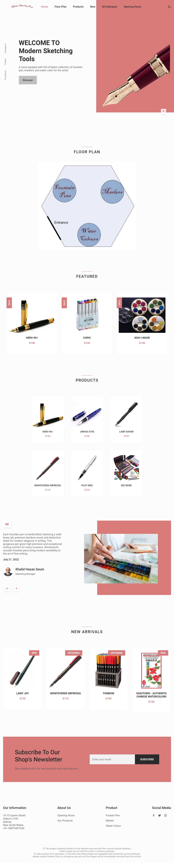

Fig 1: The full home page of the website.

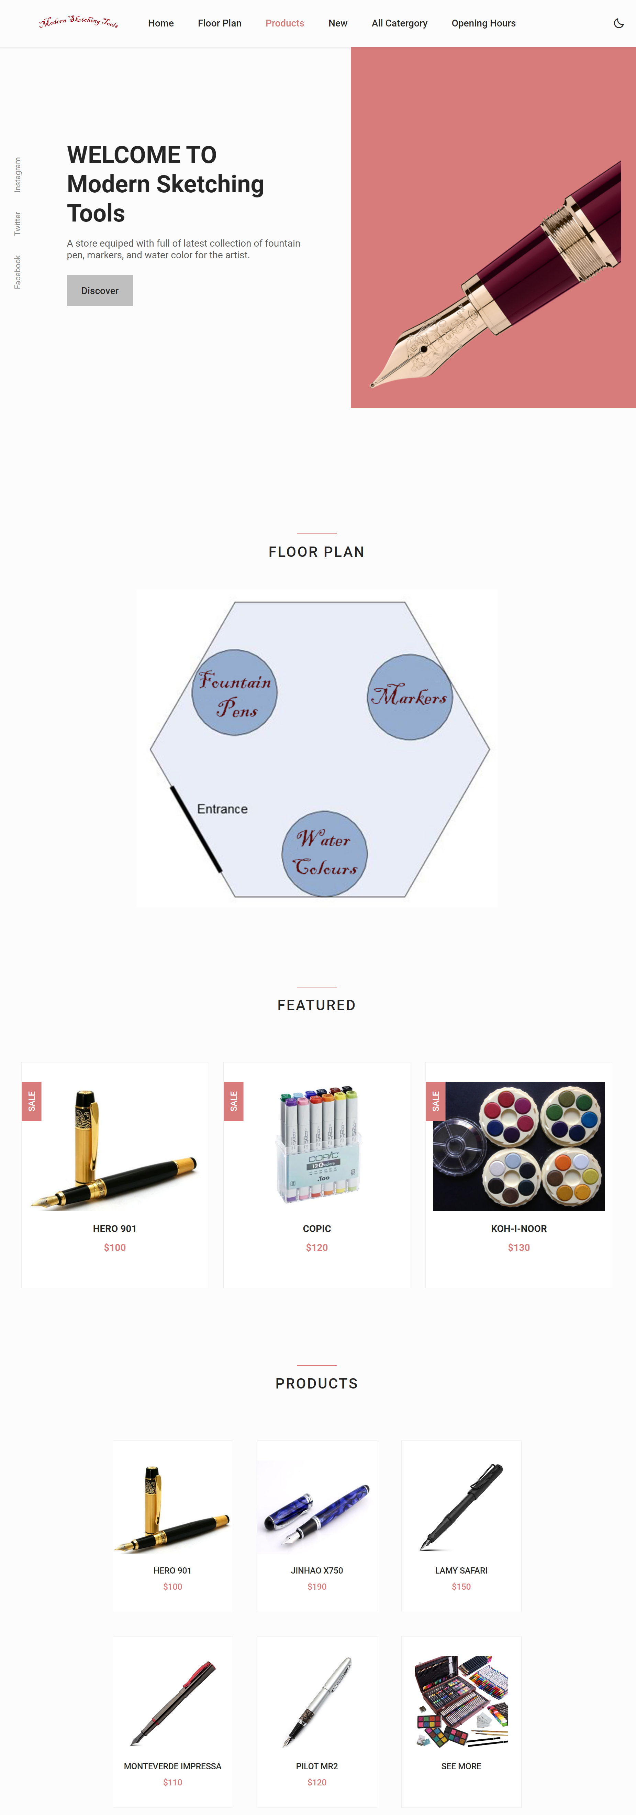

Fig 2: The home page of the website.

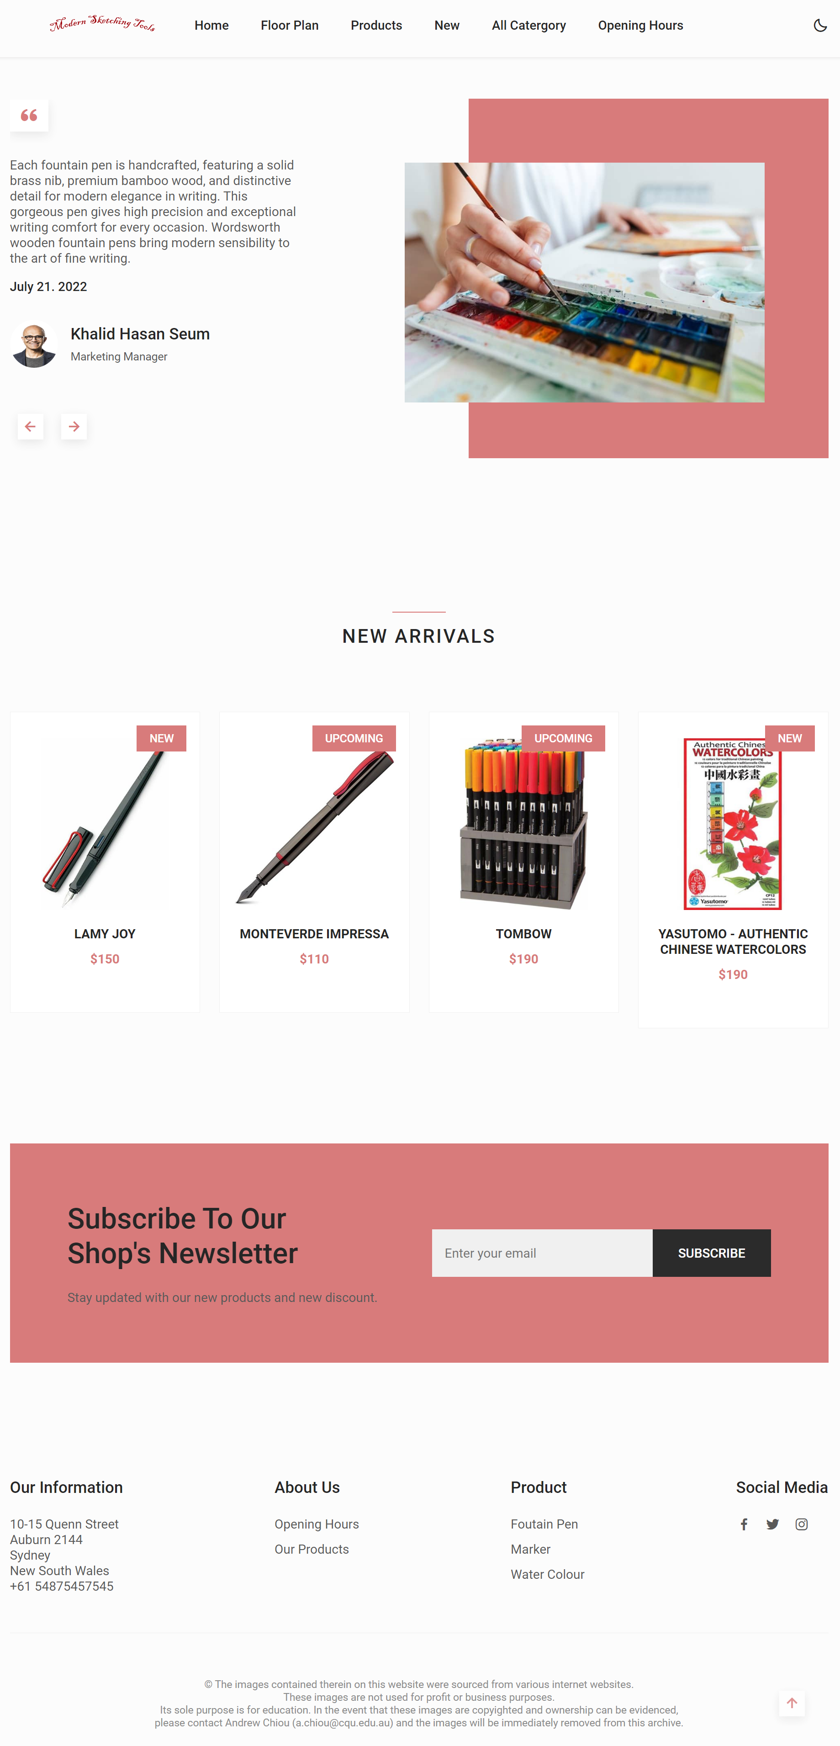

Fig 3: The home page of the website.

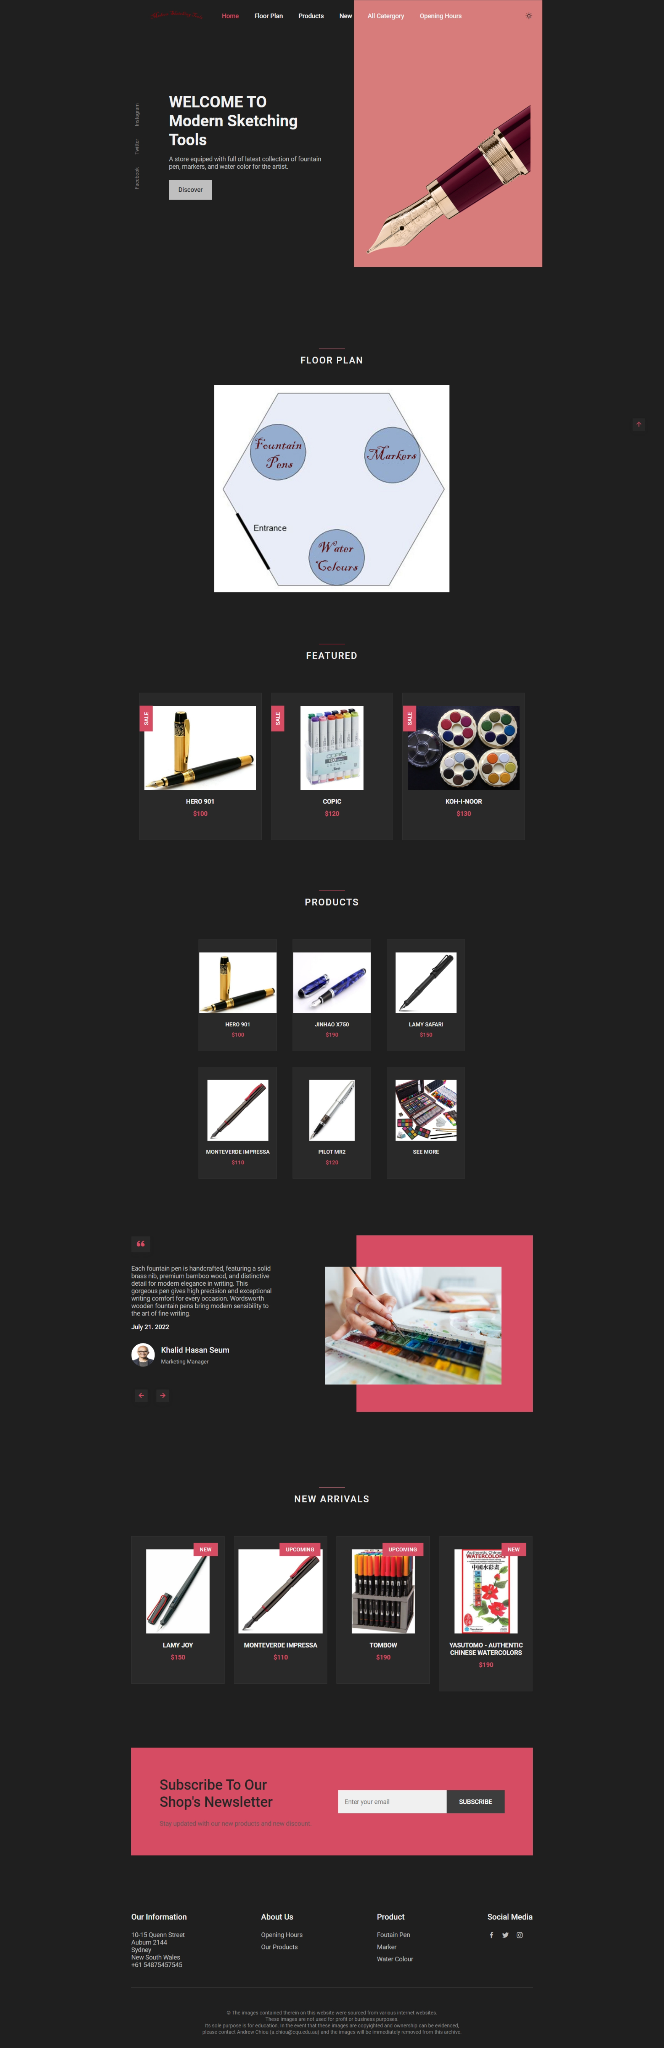

Fig 4: The home page of the website.

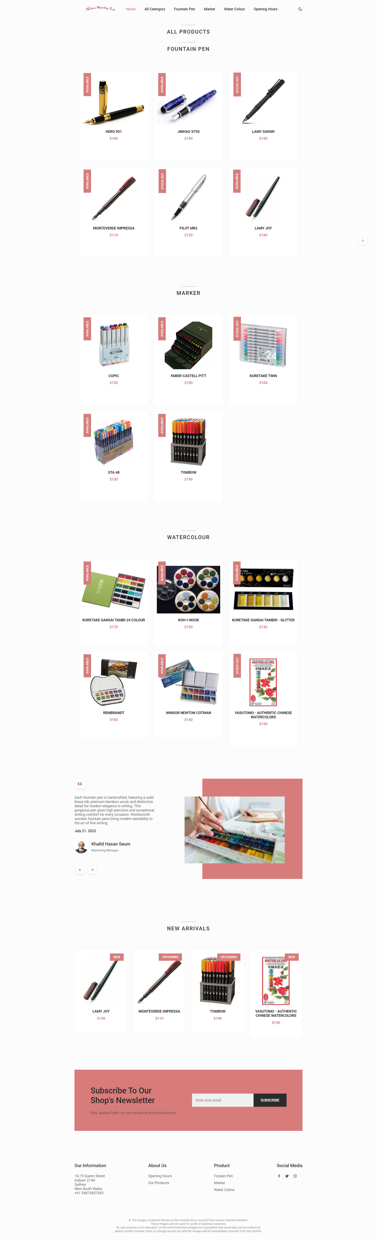

Fig 5: The All Category webpage of the website.

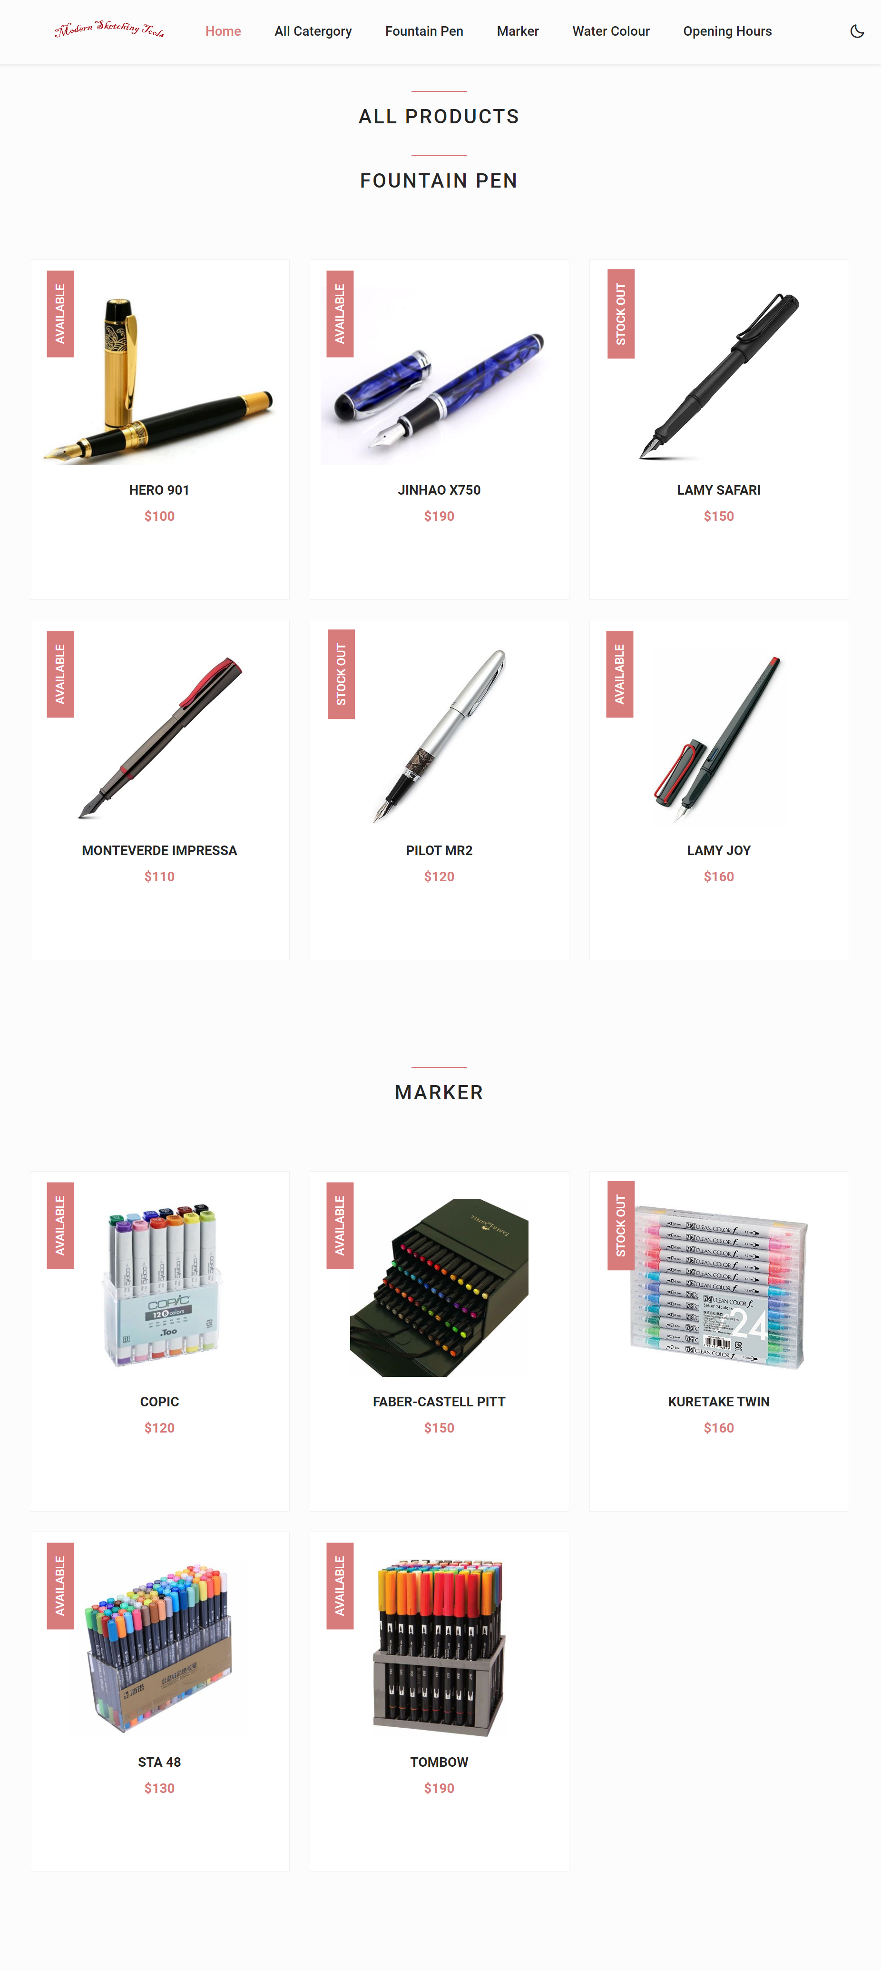

Fig 5: The All Category webpage of the website.

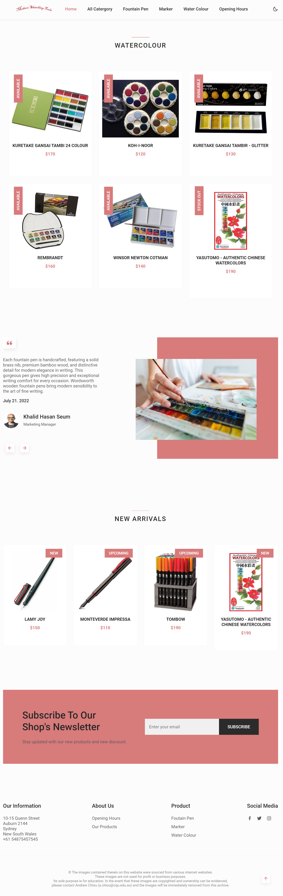

Fig 6: The All Category webpage of the website.

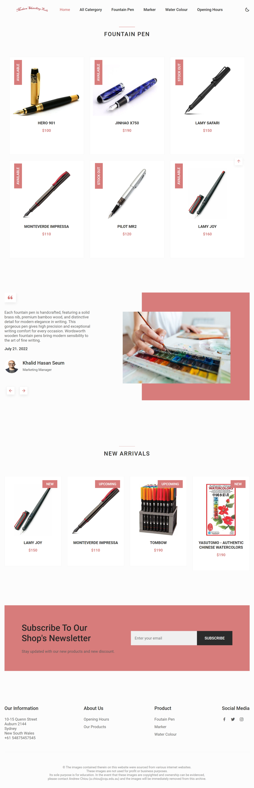

Fig 7: The Fountain Pen webpage of the website.

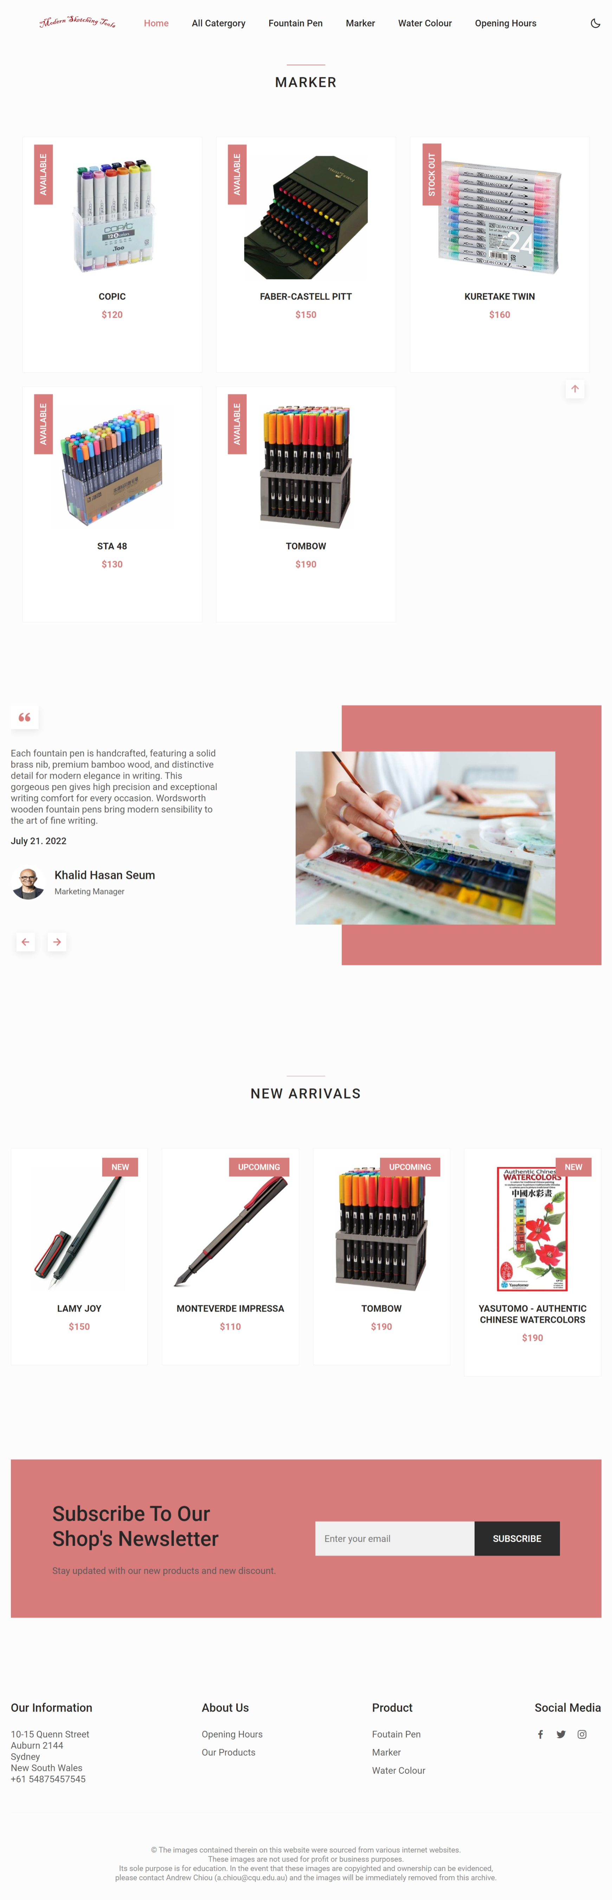

Fig 8: The Marker webpage of the website.

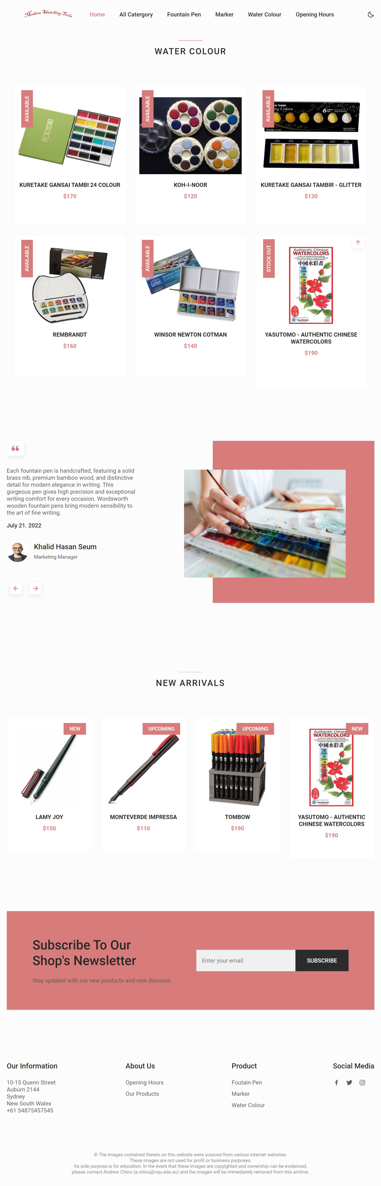

Fig 9: The *water colour* webpage of the website.

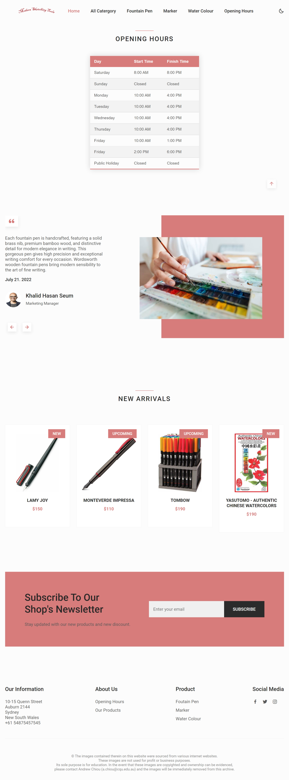

Fig 10: The *opening hour* webpage of the website.

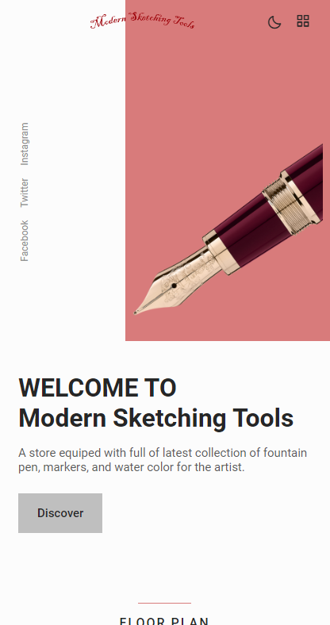

Fig 11: Mobile view of the website.

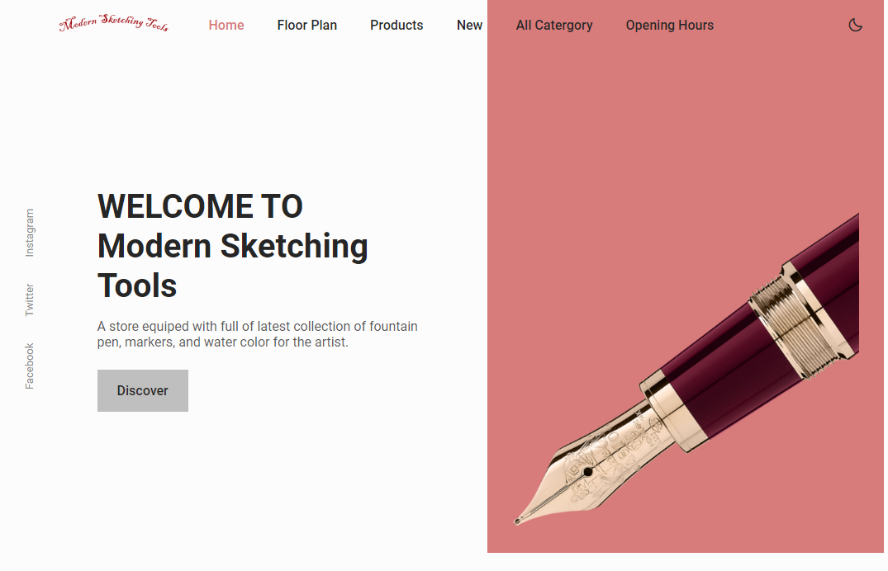

Fig 12: Tablet view of the website.